Walk for Dignity
Donation Form

April 30, 2023 • Join us at Willow Creek Park in Iowa City
View details at http://iowacityhospice.org/walk-for-dignity/
You can mail donations to Iowa City Hospice/VNA at 1526 Sycamore Street, Iowa City, IA 52240,
or deliver them to Iowa City Hospice/VNA Monday-Friday, 8am-5pm
Please make checks payable to Iowa City Hospice or VNA (or both!).
Questions? Contact Sonya Clements at 319-688-4213 or clementss@vnaic.org.

Team Name: Your Name:
Your email: Your preferred phone #:
Mailing Address: City, State, ZIP:
Create an online donor page at https://secure.frontstream.com/walk-for-dignity-2023/
Please do not include donations from your online form on this sheet.
Donor Name | Donor Address | City, State, ZIP | Donor Email | Check Amount | Cash  Amount
Please use the back of this form for additional donations.
Check total this side: $
Cash total this side: $
This page total: $
TOTAL BOTH SIDES: $

Copy this form or download it from www.iowacityhospice.org.
We will send an acknowledgement to each donor of $10 or more.
Thank you for your support!
Walk for Dignity
Donations, continued

Donor Name | Donor Address | City, State, ZIP | Donor Email | Check Amount | Cash  Amount
Thank you for your support!
Check total this side: $
Cash total this side: $
This page total: $
As a 501(c)(3) nonprofit organization, Iowa City Hospice turns no one away due to inability to pay. Our headquarters is in the heart of our service area, and all decisions are locally made. Our revenue returns to the community through patient care, staff support, and enhanced services.
VNA of Johnson County is also a 501(c)(3) nonprofit organization, serving Johnson County with
in-home and community health care since 1949.

Walk for Dignity Donation Recognition
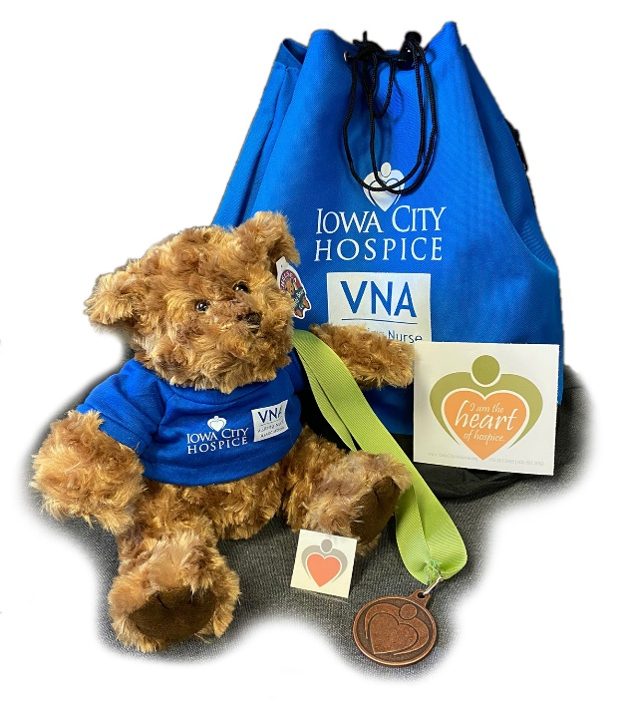
A special thank you for raising support for Iowa City Hospice
Donation Total | <$150 | $150+ | $250+ | $500+ | $1,000+
Temporary tattoo | • | • | • | • | •
Heart of Hospice sticker | • | • | • | • | •
Walk for Dignity t-shirt |  | • | • | • | •
Heart of Hospice medal |  |  | • | • | •
ICH/VNA backpack |  |  |  | • | •
Super soft teddy bear |  |  |  |  | •

